Національний технічний університет України

«Київський політехнічний інститут»

Факультет інформатики і обчислювальної техніки

Кафедра обчислювальної техніки

Лабораторна робота №1

З архітектури комп’ютерів

*Виконав:*

Студент групи ІО-12

Нестерук Ю.О.

*Перевірив:*

Поспішний О.С.

м. Київ

2012 р.

**1. Варіант завдання:**

№ ЗК: 1220

|  |  |  |  |  |  |  |
| --- | --- | --- | --- | --- | --- | --- |
| a7 | a6 | a5 | a4 | a3 | a2 | a1 |
| 1 | 0 | 0 | 0 | 1 | 0 | 0 |

|  |  |  |  |  |  |
| --- | --- | --- | --- | --- | --- |
| a7 | a6 | a5 | a4 | Функція | Розрядність операндів |
| 1 | 0 | 0 | 0 | 2С+4AB | 32 |

|  |  |  |
| --- | --- | --- |
| a3 | a2 | Тип тригера |
| 1 | 0 | RS |

|  |  |
| --- | --- |
| a1 | Тип автомата |
| 0 | Мілі |

**2. Короткі теоретичні відомості:**

В регістр, в якому зберігатиметься результат функції, заноситься значення операнда С, в окремий регістр – значення операнда А, в лічильник – В. Виконуються здвиги вліво: регістра А – два рази, регістра С – один раз. Тоді, поки на лічильнику не нуль, до значення регістра С додається значення регістра А.

**3. Структурна схема:**

**4. Блок-схеми:**

**6. Таблиця станів регістрів за тактами:**

|  |  |  |  |
| --- | --- | --- | --- |
| № | RGA | RGC | RGB |
| 0 | 00000011 | 00000001 | 00000011 |
| 1 | 00000110 | 00000010 | 00000011 |
| 2 | 00001100 | 00000010 | 00000011 |
| 3 | 00001100 | 00001110 | 00000010 |
| 4 | 00001100 | 00011010 | 00000001 |
| 5 | 00001100 | 00100110 | 00000000 |

**7. Функціональна схема (скорочений варіант):** 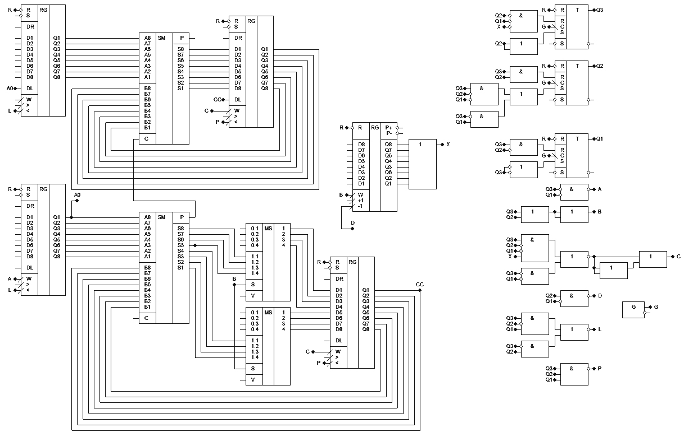

|  |  |  |  |  |  |  |  |  |  |  |  |  |  |  |  |  |  |  |  |
| --- | --- | --- | --- | --- | --- | --- | --- | --- | --- | --- | --- | --- | --- | --- | --- | --- | --- | --- | --- |
|  | Старий стан | | | Новий стан | | | УС | Сигнали збудження тригерів | | | | | | Вихідні сигнали | | | | | |
| Перехід | Q3 | Q2 | Q1 | Q3 | Q2 | Q1 | X | R3 | S3 | R2 | S2 | R1 | S1 | A | B | C | D | L | P |
| Z1-Z2 | 0 | 0 | 0 | 0 | 0 | 1 | - | - | 0 | - | 0 | 0 | 1 | ***1*** | 0 | ***1*** | 0 | 0 | 0 |
| Z2-Z3 | 0 | 0 | 1 | 0 | 1 | 1 | - | - | 0 | 0 | 1 | 0 | - | 0 | 0 | 0 | 0 | 0 | 0 |
| Z3-Z4 | 0 | 1 | 1 | 1 | 1 | 1 | - | 0 | 1 | 0 | - | 0 | - | 0 | ***1*** | 0 | 0 | ***1*** | 0 |
| Z4-Z5 | 1 | 1 | 1 | 1 | 0 | 1 | - | 0 | - | 1 | 0 | 0 | - | 0 | ***1*** | 0 | 0 | 0 | ***1*** |
| Z5-Z6 | 1 | 0 | 1 | 1 | 0 | 0 | - | 0 | - | - | 0 | 1 | 0 | 0 | ***1*** | 0 | 0 | ***1*** | 0 |
| Z6-Z7 | 1 | 0 | 0 | 1 | 1 | 0 | 1 | 0 | - | 0 | 1 | - | 0 | 0 | ***1*** | ***1*** | 0 | 0 | 0 |
| Z7-Z6 | 1 | 1 | 0 | 1 | 0 | 0 | - | 0 | - | 1 | 0 | - | 0 | 0 | ***1*** | 0 | ***1*** | 0 | 0 |
| Z6-Z8 | 1 | 0 | 0 | 0 | 1 | 0 | 0 | 1 | 0 | 0 | 1 | - | 0 | 0 | ***1*** | 0 | 0 | 0 | 0 |

|  |  |  |  |  |  |
| --- | --- | --- | --- | --- | --- |
|  | Q2 | |  |  | R3 |
| Q3 | 0 | 0 | 0 | 1 |  |
| 0 | 0 | 0 | 0 | Q1 |
|  | 0 | 0 | - | - |
|  | - | - | - | - |  |
|  |  | X | |  |  |

|  |  |  |  |  |  |
| --- | --- | --- | --- | --- | --- |
|  | Q2 | |  |  | S3 |
| Q3 | - | - | - | 0 |  |
| - | - | - | - | Q1 |
|  | 1 | 1 | 0 | 0 |
|  | - | - | 0 | 0 |  |
|  |  | X | |  |  |

|  |  |  |  |  |  |
| --- | --- | --- | --- | --- | --- |
|  | Q2 | |  |  | R1 |
| Q3 | - | - | - | - |  |
| 0 | 0 | 1 | 1 | Q1 |
|  | 0 | 0 | 0 | 0 |
|  | - | - | 0 | 0 |  |
|  |  | X | |  |  |

|  |  |  |  |  |  |
| --- | --- | --- | --- | --- | --- |
|  | Q2 | |  |  | R2 |
| Q3 | 1 | 1 | 0 | 0 |  |
| 1 | 1 | - | - | Q1 |
|  | 0 | 0 | 0 | 0 |
|  | - | - | - | - |  |
|  |  | X | |  |  |

|  |  |  |  |  |  |
| --- | --- | --- | --- | --- | --- |
|  | Q2 | |  |  | S2 |
| Q3 | 0 | 0 | 1 | 1 |  |
| 0 | 0 | 0 | 0 | Q1 |
|  | - | - | 1 | 1 |
|  | - | - | 0 | 0 |  |
|  |  | X | |  |  |

|  |  |  |  |  |  |
| --- | --- | --- | --- | --- | --- |
|  | Q2 | |  |  | S1 |
| Q3 | 0 | 0 | 0 | 0 |  |
| - | - | 0 | 0 | Q1 |
|  | - | - | - | - |
|  | - | - | 1 | 1 |  |
|  |  | X | |  |  |

|  |  |  |  |  |  |
| --- | --- | --- | --- | --- | --- |
|  | Q2 | |  |  | A |
| Q3 | 0 | 0 | 0 | 0 |  |
| 0 | 0 | 0 | 0 | Q1 |
|  | 0 | 0 | 0 | 0 |
|  | - | - | 1 | 1 |  |
|  |  | X | |  |  |

|  |  |  |  |  |  |
| --- | --- | --- | --- | --- | --- |
|  | Q2 | |  |  | B |
| Q3 | 1 | 1 | 1 | 1 |  |
| 1 | 1 | 1 | 1 | Q1 |
|  | 1 | 1 | 0 | 0 |
|  | - | - | 0 | 0 |  |
|  |  | X | |  |  |

|  |  |  |  |  |  |
| --- | --- | --- | --- | --- | --- |
|  | Q2 | |  |  | C |
| Q3 | 0 | 0 | 1 | 0 |  |
| 0 | 0 | 0 | 0 | Q1 |
|  | 0 | 0 | 0 | 0 |
|  | - | - | 1 | 1 |  |
|  |  | X | |  |  |

|  |  |  |  |  |  |
| --- | --- | --- | --- | --- | --- |
|  | Q2 | |  |  | D |
| Q3 | 1 | 1 | 0 | 0 |  |
| 0 | 0 | 0 | 0 | Q1 |
|  | 0 | 0 | 0 | 0 |
|  | - | - | 0 |  |  |
|  |  | X | |  |  |

|  |  |  |  |  |  |
| --- | --- | --- | --- | --- | --- |
|  | Q2 | |  |  | L |
| Q3 | 0 | 0 | 0 | 0 |  |
| 0 | 0 | 1 | 1 | Q1 |
|  | 1 | 1 | 0 | 0 |
|  | - | - | 0 | 0 |  |
|  |  | X | |  |  |

|  |  |  |  |  |  |
| --- | --- | --- | --- | --- | --- |
|  | Q2 | |  |  | P |
| Q3 | 0 | 0 | 0 | 0 |  |
| 1 | 1 | 0 | 0 | Q1 |
|  | 0 | 0 | 0 | 0 |
|  | - | - | 0 | 0 |  |
|  |  | X | |  |  |

Мінімізовані функції: